ABOUT UNITY
Unity is a popular 2D/3D game engine used by big and small studios alike. Since it’s a well-rounded game engine, you will be able to build and play your games on your Macs, PCs or via a web portal. You can read more about the engine at http://docs.unity3d.com/Manual/index.html, which also includes a full reference for the engine’s features.

PROJECT FOLDER SETUP
In order to work on any game effectively, you should create a clean folder to hold all of the separate projects in an organized fashion. This will help isolate your programming stuff from previous and future classes, and by using a consistent naming scheme, will also help me be able to help you find what you need faster.

If you already have a layout that you like and works, by all means, stick w/ it, otherwise try the following.

To begin, create a new folder on your computer (typically in the My Documents folder or similar location) then name it “PGF1 Projects - <month> <year>”. Replace the words <month> and <year> with the current month and year; for example, you could name it “PGF1 Projects - Jan 2019”. All of your projects in this class will be created and worked on from inside this folder.

TURN-IN REQUIREMENT
You must have reviewed this entire assignment, installed Unity 2018, created a 3D Unity project named UnitySetup, and made sure Visual Studio opens Unity C# files (preferably from inside Unity).
Create a new C# script and name it LastNameFirstName_UnitySetup (replacing LastNameFirstName w/ yours).
Open that file in Visual Studio, and place the 2 programs side by side.
Take a screenshot, name it LastNameFirstName_UnitySetup (replacing LastNameFirstName w/ yours) and upload it to FSO. The screenshot format can be png, bmp, jpg, or gif, and can be captured using the Snipping Tool.
Your image should look something like this:
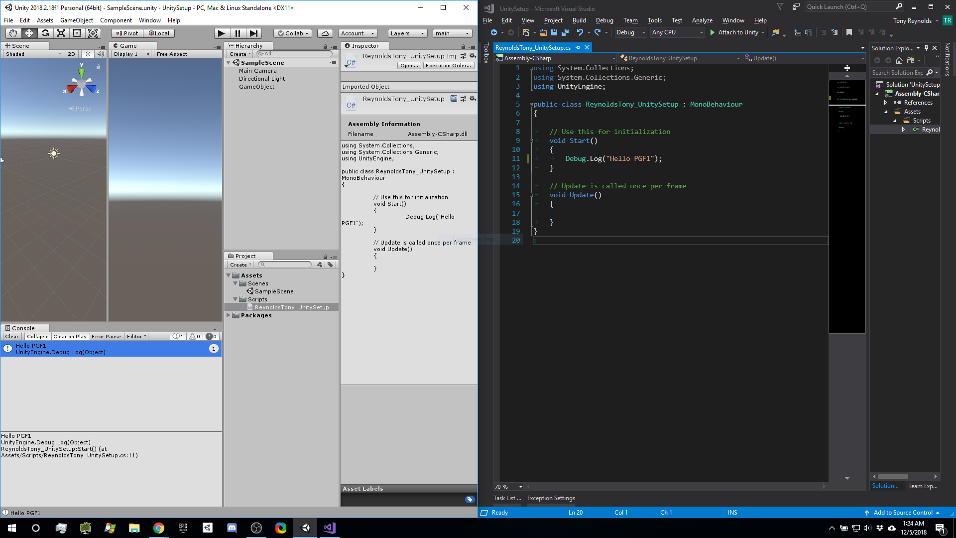

Screenshot in Windows:
Taking screenshots on Windows takes only pressing the Print Screen (prt screen) button.
Screenshot in Boot Camp / lack of dedicated Print Screen key:
Use the Snipping Tool (similar to the Grab tool in macOS): https://support.microsoft.com/en-us/help/13776/windows-use-snipping-tool-to-capture-screenshots or depending on your Boot Camp drivers/configuration, the keys Fn+Shift+F11 is supposed to emulate the key.
(ref: https://apple.stackexchange.com/questions/177834/how-to-take-screenshot-in-boot-camp)

